TEST CASES

GALLERIA E-ART

|  |  |  |  |
| --- | --- | --- | --- |
|  | **Prepared By / Last Updated By** | **Reviewed by** | **Approved By** |
| **Name** | **1. Balaji Ravindaran (2128548)**  **2. Gokul Raj K (2128799)**  **3. Jayapradaa G (2128402)**  **4. Sanjay Kumar S (2128447)**  **5. Sneka J (2150786)** |  |  |
| **Role** | 1. Pod Leader  2. Pod Member  3. Pod Member  4. Pod Member  5. Pod Member |  |  |
| **Signature** |  |  |  |
| **Date** | 02-05-2023 |  |  |

HOME PAGE

TEST CASE 1:

Initial state when neither the members nor the admin is logged in:



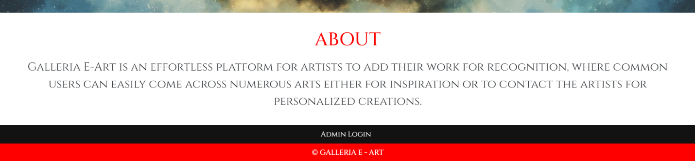

Desired outcome: Only the “log in and signup links” should be visible.

Obtained outcome: Same as the desired outcome.

Result: Test passes successfully

TEST CASE 2:

When the artist with active profile status is logged in:



Desired outcome:

* When the artist is logged in, the special “art management link” should be visible.
* Additionally, the “view arts link” should also be visible.
* The “log in and signup links” should be replaced with “logout and profile page links”.

Obtained outcome: Same as the desired outcome.

Result: Test passes successfully

TEST CASE 3:

When the artist with inactive or pending profile status is logged in:



Desired outcome:

* When the artist with inactive or pending profile status has logged in only the “view arts link” should be visible.
* The “log in and signup links” should be replaced with “logout and profile page links”.

Obtained outcome: Same as the desired outcome.

Result: Test passes successfully

TEST CASE 4:

When the general user is logged in:



Desired outcome:

* When the general user has logged in only the “view arts link” should be visible.
* The “log in and signup links” should be replaced with “logout and profile page links”.

Obtained outcome: Same as the desired outcome.

Result: Test passes successfully

TEST CASE 5:

When the admin is logged in:





Desired outcome:

* When the admin has logged in, the “admin login link” should be replaced with the “member management link”.
* The “log in and signup links” should be replaced with “logout and profile page links”.

Obtained outcome: Same as the desired outcome.

Result: Test passes successfully

LOGIN PAGE

TEST CASE 1:

When users try to log in with any empty fields:

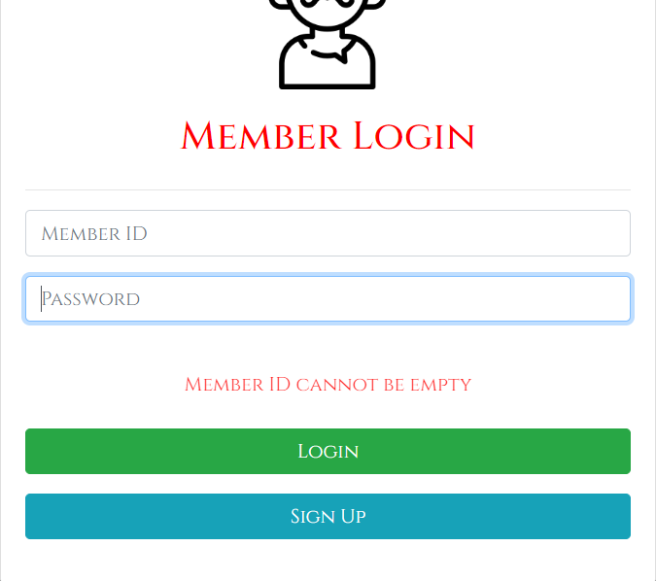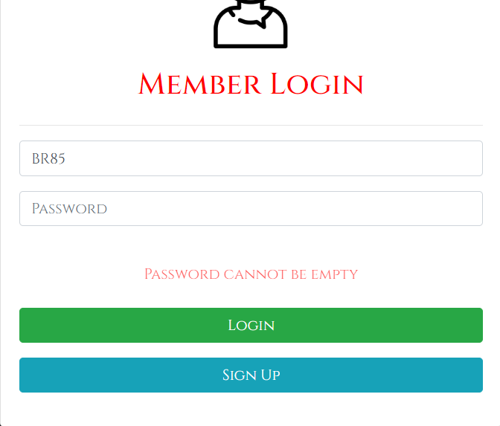

Desired outcome:

* The user should not be logged in or redirected to any other pages.
* An appropriate error description should be displayed for the user.

Obtained outcome: Same as the desired outcome.

Result: Test passes successfully

TEST CASE 2:

When users try to log in with invalid credentials:

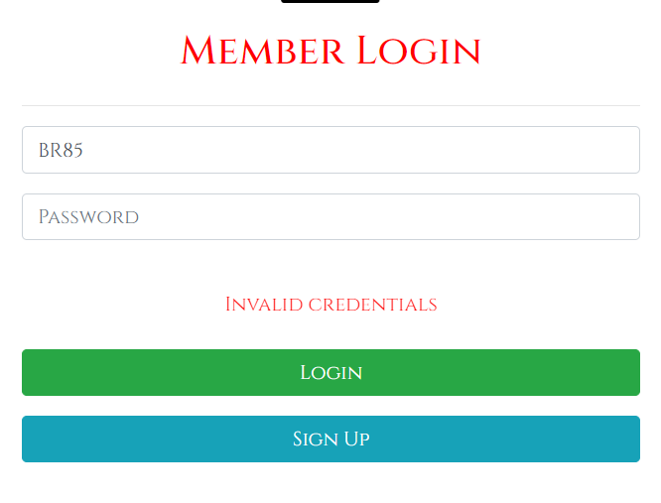

Desired outcome:

* The user should not be logged in or redirected to any other pages.
* An appropriate error description should be displayed for the user.

Obtained outcome: Same as the desired outcome.

Result: Test passes successfully

TEST CASE 3:

On successful user login:



Desired outcome:

* The user should be logged in and redirected to the home page.

Obtained outcome: Same as the desired outcome.

Result: Test passes successfully

SIGNUP PAGE

TEST CASE 1:

When users try to signup with any empty fields:

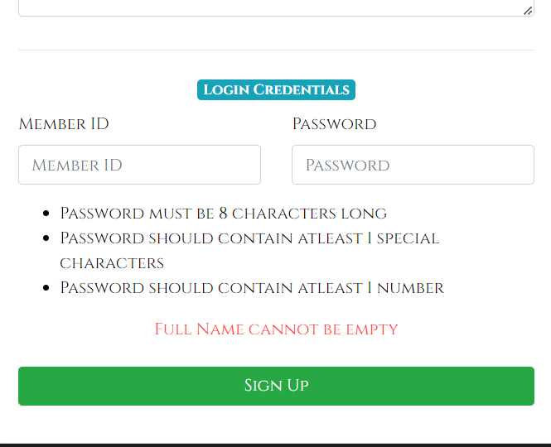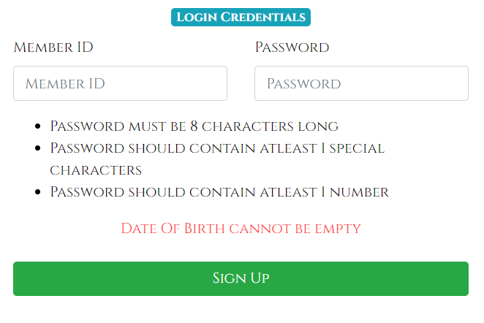

Desired outcome:

* The user account should not be created or redirected to any other pages.
* An appropriate error description should be displayed for the user.

Obtained outcome: Same as the desired outcome.

Result: Test passes successfully

TEST CASE 2:

When the user tries to signup with pre-existing member ID:

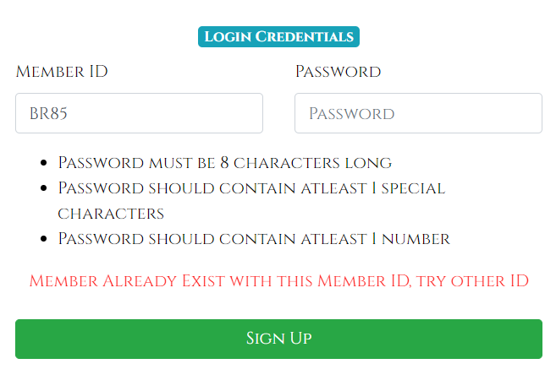

Desired outcome:

* The user account should not be created or redirected to any other pages.
* An appropriate error description should be displayed for the user.

Obtained outcome: Same as the desired outcome.

Result: Test passes successfully

TEST CASE 3:

When the user tries to signup with a password that does not meet the criteria:

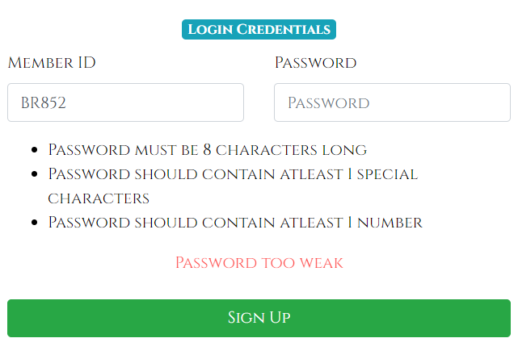

Desired outcome:

* The user account should not be created or redirected to any other pages.
* An appropriate error description should be displayed for the user.

Obtained outcome: Same as the desired outcome.

Result: Test passes successfully

TEST CASE 4:

On successful user signup:

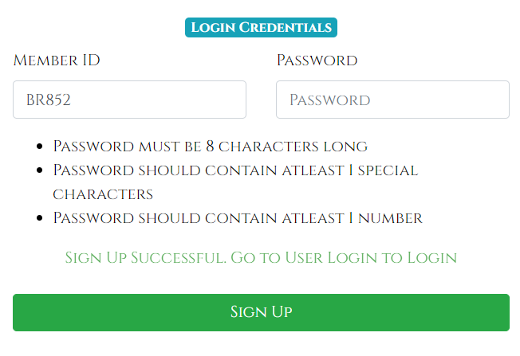

Desired outcome:

* The user account should be created.
* An appropriate description should be displayed for the user.

Obtained outcome: Same as the desired outcome.

Result: Test passes successfully

MEMBER MANAGEMENT PAGE

TEST CASE 1:

When the admin tries to change the account status of a user or delete a user permanently without providing a member ID or by providing an invalid member ID:

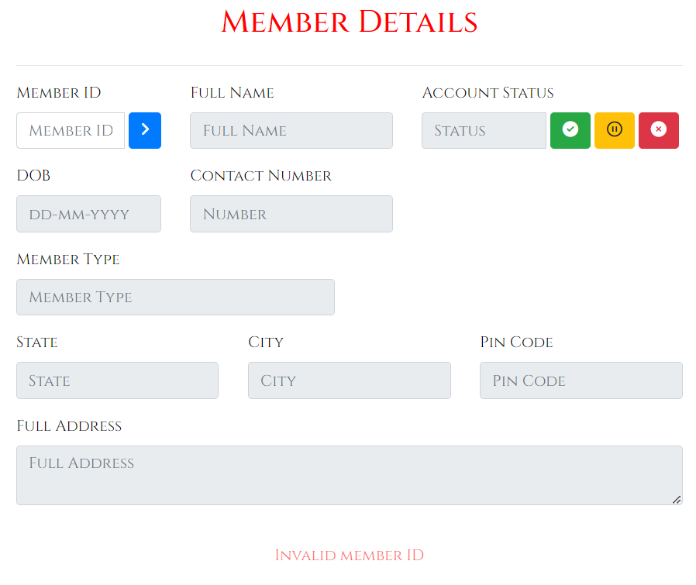

Desired outcome:

* The user account should not be deleted.
* The user account status should not be changed.
* An appropriate error description should be displayed for the admin.

Obtained outcome: Same as the desired outcome.

Result: Test passes successfully

TEST CASE 2:

On successfully updating the user account status:

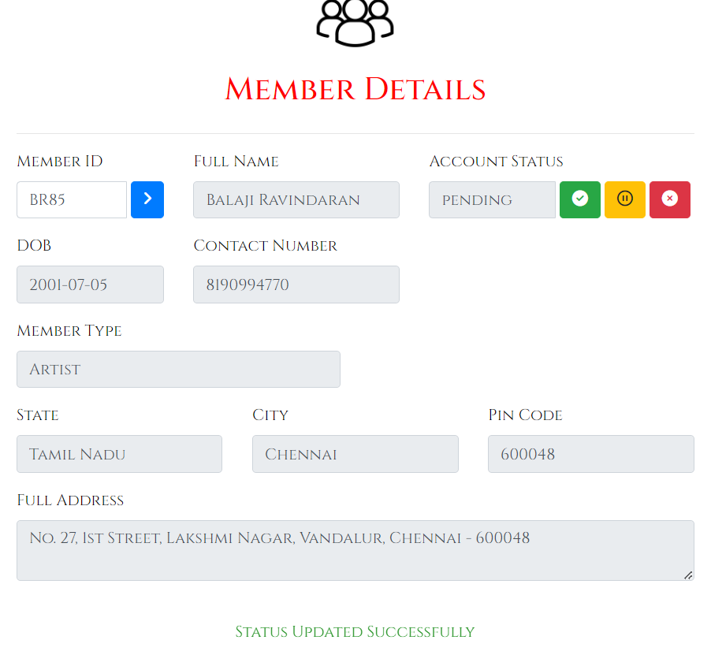

Desired outcome:

* The user account status should be updated.
* An appropriate description should be displayed for the admin.

Obtained outcome: Same as the desired outcome.

Result: Test passes successfully

TEST CASE 3:

On successfully deleting the user account:

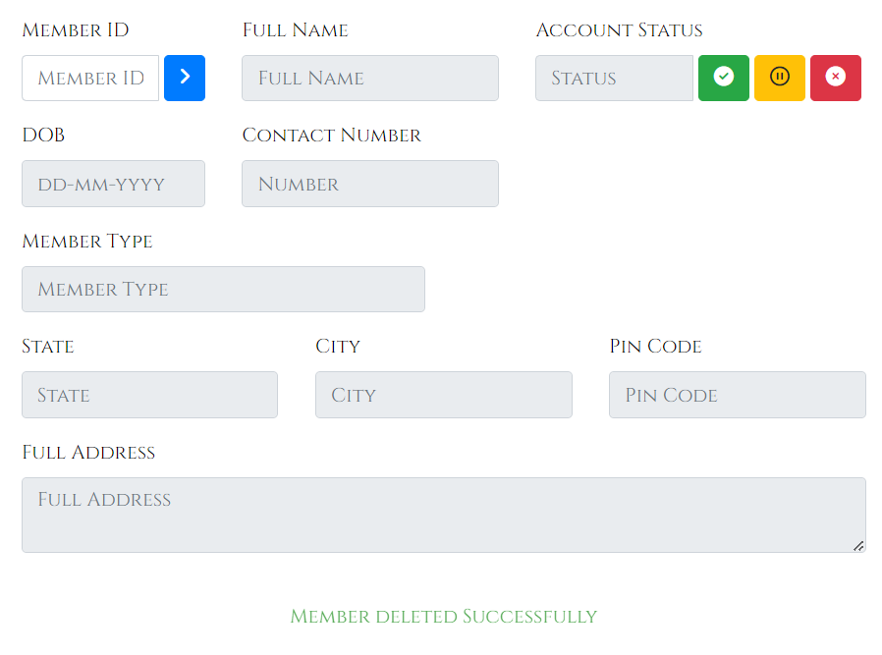

Desired outcome:

* The user account should be deleted.
* An appropriate description should be displayed for the admin.

Obtained outcome: Same as the desired outcome.

Result: Test passes successfully

ART MANAGEMENT PAGE

TEST CASE 1:

When the artist tries to add art with any empty fields:

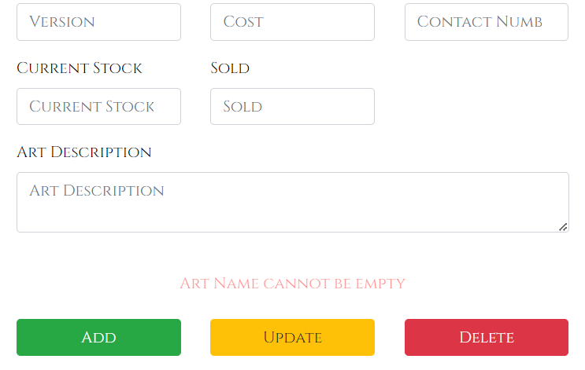

Desired outcome:

* The art should not be added.
* An appropriate error description should be displayed for the artist.

Obtained outcome: Same as the desired outcome.

Result: Test passes successfully

TEST CASE 2:

When the artist tries to update or delete art details with no or invalid art ID:

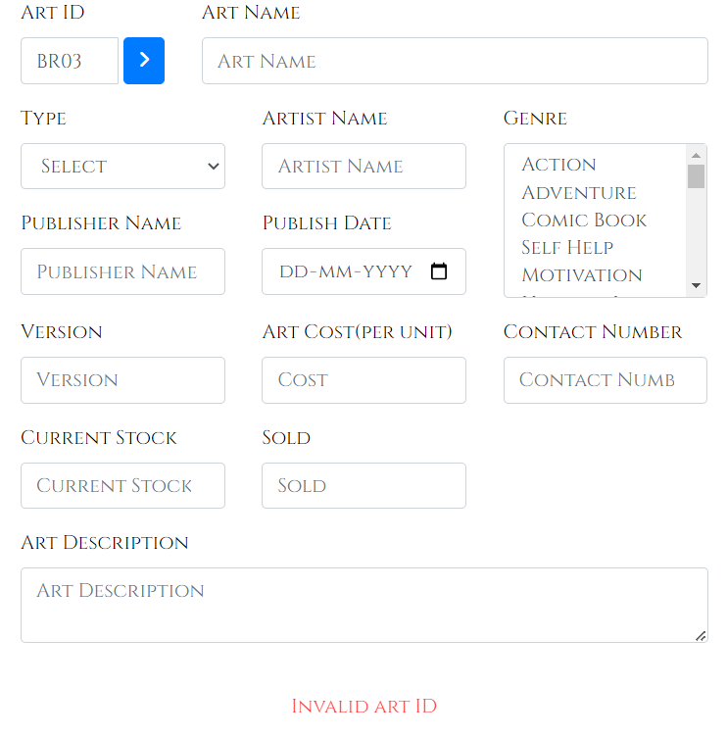

Desired outcome:

* The art should not be updated or deleted.
* An appropriate error description should be displayed for the artist.

Obtained outcome: Same as the desired outcome.

Result: Test passes successfully

TEST CASE 3:

When the artist tries to add art with pre-existing art ID:

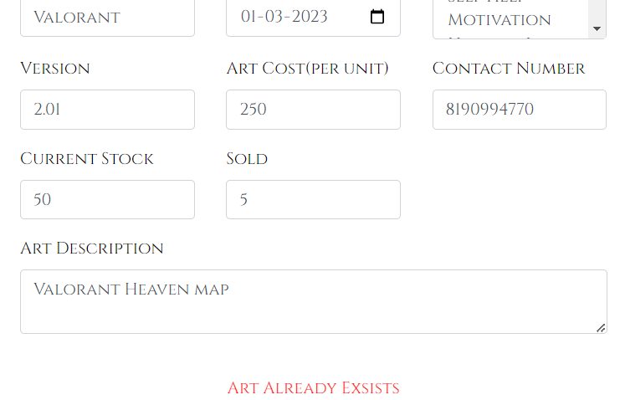

Desired outcome:

* The art should not be added.
* An appropriate error description should be displayed for the artist.

Obtained outcome: Same as the desired outcome.

Result: Test passes successfully

TEST CASE 4:

On successfully adding an art:

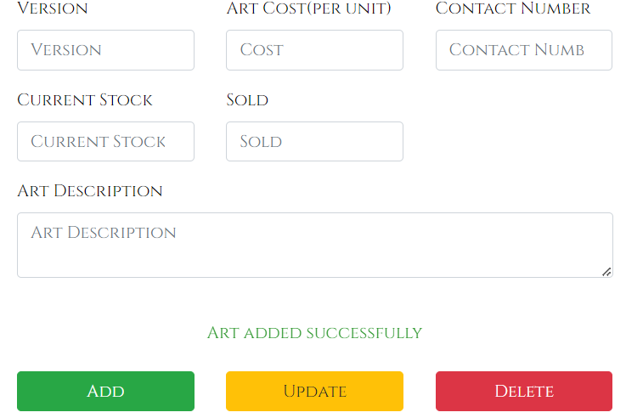

Desired outcome:

* The art should be added.
* An appropriate description should be displayed for the artist.

Obtained outcome: Same as the desired outcome.

Result: Test passes successfully

TEST CASE 5:

On successfully updating or deleting an art:

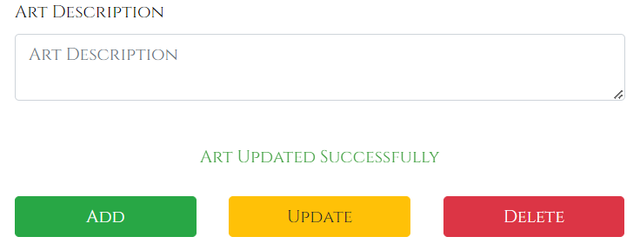

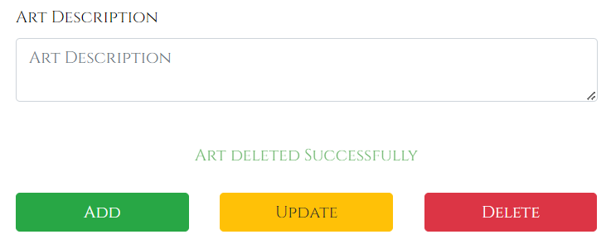

Desired outcome:

* The art should be updated or deleted.
* An appropriate description should be displayed for the artist.

Obtained outcome: Same as the desired outcome.

Result: Test passes successfully

VIEW ART PAGE

TEST CASE 1:



Desired outcome:

* All the available art should be displayed with appropriate details.

Obtained outcome: Same as the desired outcome.

Result: Test passes successfully

PROFILE PAGE

TEST CASE 1:

When the user tries to update the profile with empty fields:

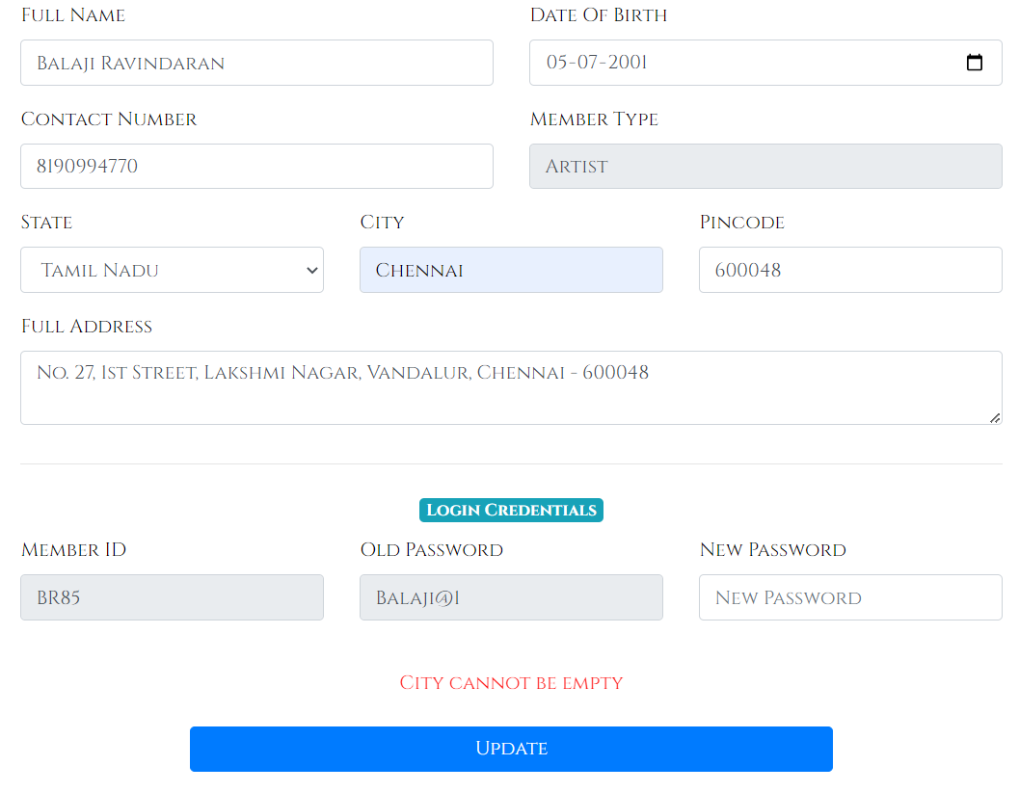

Desired outcome:

* The user profile should not be updated.
* An appropriate error description should be displayed for the user.

Obtained outcome: Same as the desired outcome.

Result: Test passes successfully

TEST CASE 2:

On successfully updating the user profile:

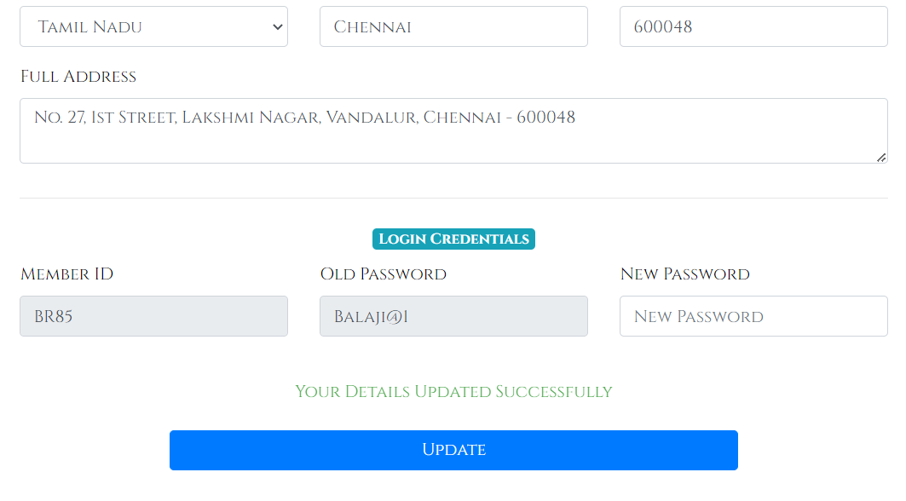

Desired outcome:

* The user profile should be updated.
* An appropriate description should be displayed for the user.

Obtained outcome: Same as the desired outcome.

Result: Test passes successfully

TEST CASE 3:

Viewing the user account status:



Desired outcome:

* The user account status should be presented appropriately according to the changes made by the admin.

Obtained outcome: Same as the desired outcome.

Result: Test passes successfully